CV’s MELANGELL - HONEY ANGEL

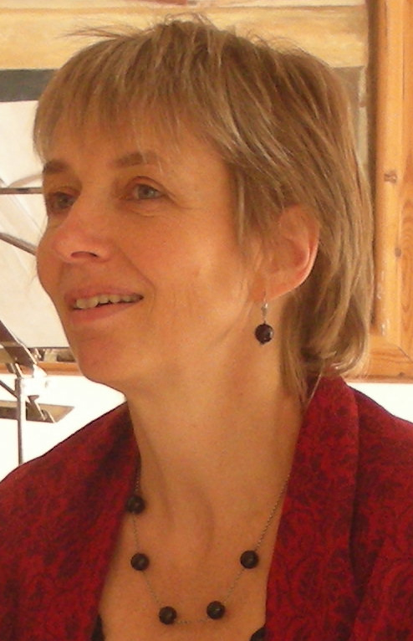

HANNE TOFTE JESPERSEN (DK)

- composer, ensemble leader. Pianist and singer

Her compositions reflect her broad background in both classical, choral and contemporary music including world music. In 2014 her new innovative project   
*If the land could speak* is commissioned by Roskilde District to be realised in twenty kindergardens*.* Based on her walks with 4-5 yr old children in their local areas, she composes interactive wórks including a specific song for each institution, scored for childrens voices and various acoustic trio constallations. Roskilde District, Danish Arts Foundation and Danish Musicians Union are the main sponsors.

Oct 2013 *The Return of Dame Heurodis from the Otherworld* was first performed in Frederiksborg Castle Church, commissioned by the duo Sven-Ingvart Mikkelsen, organ & Jens Rømer, bombarde. An instrumental piece based on a Breton medieval magical poem, with composer's fee from Hillerød District.

April 2013 her 40 min music tale *Farvespillet/ The Play of Colours* was first performed in Radio Denmark's Concert House*.* An interactive piece for violin, clarinet, bassoon, percussion, storyteller and the voices and movements of an audience of 5-8 yr old children,   
commissioned by DR-Musikariet and Danish Composers Association, with composer's fee from the Danish Arts Foundation.

Initiator and artistic leader of Music for the Mysteries (MftM) formed 2007 for whom she has set the tale of the female saint and mystic Melangell to music (64 min, 2011), on CD 2012 at Meridian Records, UK; first performed as total art with visual installation by Alison Michell during the Schubertiade 2011 in coll. with Museum of Contemporary Art, with composer's fee from the Danish Arts Foundation. Other works for MftM include "The Seven Natures" from 2007, recorded and released on the ensemble's first CD from 2009.

Other commissioned works include *Suite for poems by George Herbert* for SAT soloists, mixed choir, violin, double bass, organ, 2010, 20 min). Seven of her works for childrens choir published by Dansk Sang 2008.  
She wrote story and part of the music for Insektudsigten/ Insects' weather forecast - an interactive childrens concert with 99 performances 2004-13, CD 2006.   
Co-leader & consultant of the Danida sponsored cultural project Agoro in Ghana 1993-2000, leader of the world music orchestra Agoro Band (Ghana/DK) 1995-03, CD 2001; artistic leader and producer of dance performances with Ghanaian and Danish artists, incl for World.dk, Images of Africa ‘96, Agoro Festival 99.

Educations: Cand.mag in music (MA) and film (BA) from University of Copenhagen.   
Organist (PO) from Church Music School of Zealand. Organist and choir conductor at Ny Vor Frue Kirke since 2001.  
Has received artists working grants from the Danish Arts Foundation and from Djbfa, mobility grants from Nordic Culture Point. Has been in charge of tour projects with collaboration partners in the Nordic Countries, UK and Ghana.

<http://www.musicforthemysteries.org/hannetoftejespersen_uk.php>

VOCAL SOLOISTS

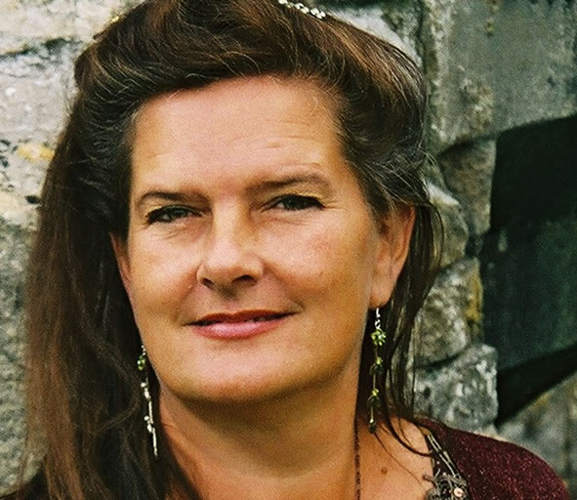

AGNETHE CHRISTENSEN (SE/DK)

- contralto and kantele. Sings Melangell

Grew up in Sweden and has her roots in both classical and folk music. Has specialised in medieval ballad traditions and holds an internally acclaimed carrier within early music. After vocal studies at The Royal Danish Music Acedemy she studied "Early singing technique" with Andrea von Ramm in Basel and also in Paris and Rome. Has recorded an immense number of CDs and performed worldwide within early and baroque music and also modern opera. Since 2001 she has been member of Benjamin Bagby's international group Sequentia whose performances include tales from the Edda. Other groups include duo ALBA, trio ULV with Lena Susanne Norin and Elizabeth Gaver whose focus is early Swedish music, and duo with harpist Leah Stuttard.

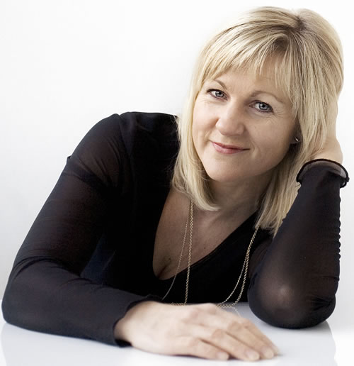

<http://www.agnethechristensen.org>

BENTE VIST (NO/DK)

- soprano soloist

Norwegian soprano, based in DK. Educated from Norwegian Music Academy, Julliard School of Music and The Royal Danish Music Acedemy. Besides her many engagements as a soloist in oratoria and choral works with symphony orchestras in DK and Norway, she is a highly reputed interpretor of contemporay music; Per Nørgård, Bo Holten, Palle Mikkelborg a.o. has composed spec. for her. Member of Paul Hillier's group *Theatre of the Voices.* Has appeared in several contemporary music dramas incl. w Hotel Pro Forma and Hollandhouse, and recorded many CDs.  
VOCAL SOLOISTS - *continued*

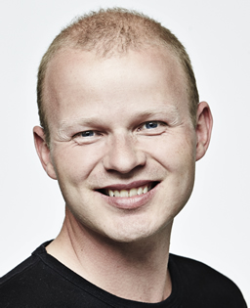

JAKOB SKJOLDBORG (DK)

- tenor soloist

As a singer Jakob Skjoldborg is autodidact with a background in both rock, musical and classical music. He is member of the vocal ensemble Ars Nova Copenhagen and appears regularly with Mogens Dahl Chamber Choir, Radio Denmark's Chamber Choir and DR Concert Choir, Irish National Chamber Choir a.o. His focus as a soloist is primarily on renaissance, baroque and contemporary music. He is co-founder of Holmens Mail Quartet whp performs pop as well as Palestrina equally charming. Has also released two albums with the indie rock band Windermere.   
Jakob also holds a MA in Danish and a BA in linguistic psychology. <http://jakobskjoldborg.dk/>

TEIT KANSTRUP (DK)

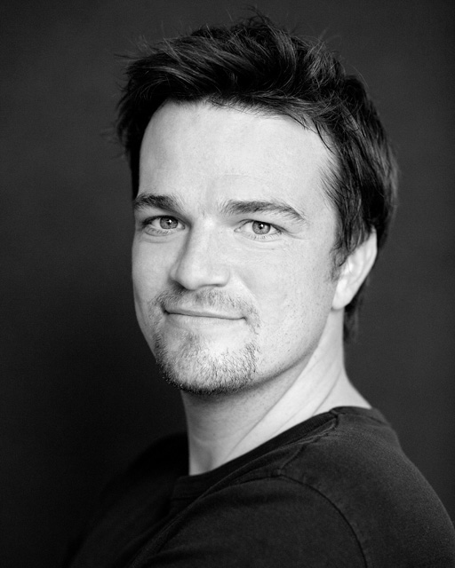

- baritone soloist. Sings Prince of Brochwell

Educated from The Royal Danish Music Acedemy and from Royal Academy of   
Opera in London where he a.o. has sung the main role in The Marriage of Figaro conducted by Sir Colin Davis. Very often appears as solioist in oratoria and choral work, incl. Mozart's Requiem with Aarhus Symphony Orchestra and Brahms' Requiem with the Savannah Philharmonic, US. Engaged by opera compagnies in DK and abroad. Later key roles include Puccini's La Boheme, Don Giovanni,, Dandini in Rossini's Cinderella w Opera on Location / Oresunds operan; US-debute in 2011 as Guglielmo i Mozart's Cosi fan tutte.

<http://oresundsoperan.se/teit-kanstrup-baryton>

INSTRUMENTALISTS

KUNO KJÆRBYE (DK)  
- violinist

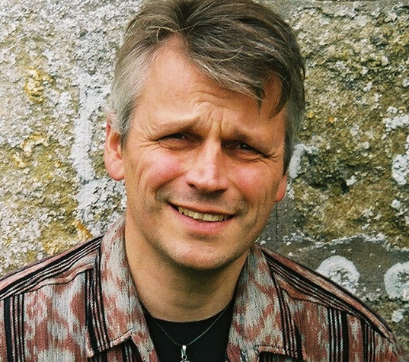

Educated soloist from The Royal Danish Music Acedemy with debute concert 1985. A most versatile chamber musician, incl. in duo with pianist   
Kirsten Beyer-Karlshøj; has first performed many works by contemporary Danish and Latvian composers. Composer; Kuno's many works include music for Soeren Kierkegaard's Philosophical Fragments (2013), Henrik Ibsen's drama “The Lady from the Sea” in a Mexican-Norwegian co-production 2006. In 2009 music for visual concert commissioned by the Vikingships Museum on the journey of the Sea Stallion from Roskilde to Dublin, released on cd & dvd 2010.

[www.kunokjaerbye.dk](http://www.kunokjaerbye.dk)

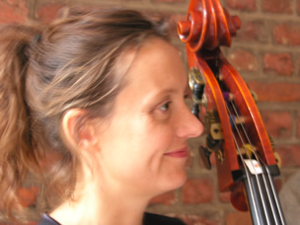

IDA BACH JENSEN (DK)  
- double bassist; on maternity leave in 2014.

Educated in Paris at the Nadia Boulanger Conservatory and with Francois Rabbath as her teacher 1995-2000, freelance musician and composer. Appears solo with own electro-akustic works. Has composed for dance performances, theatre, film, incl. for a film on the Swedish poet Gunnar Ekeløf. Performs with Martin Hall, Lisbeth Diers, Birgit Løkke a.o. Often collaborates with visual artists and poets. Debute as film documentarist in 2013 with the acclaimed "Composer" portraying the creative proces of three composers. <http://idabachjensen.dk>

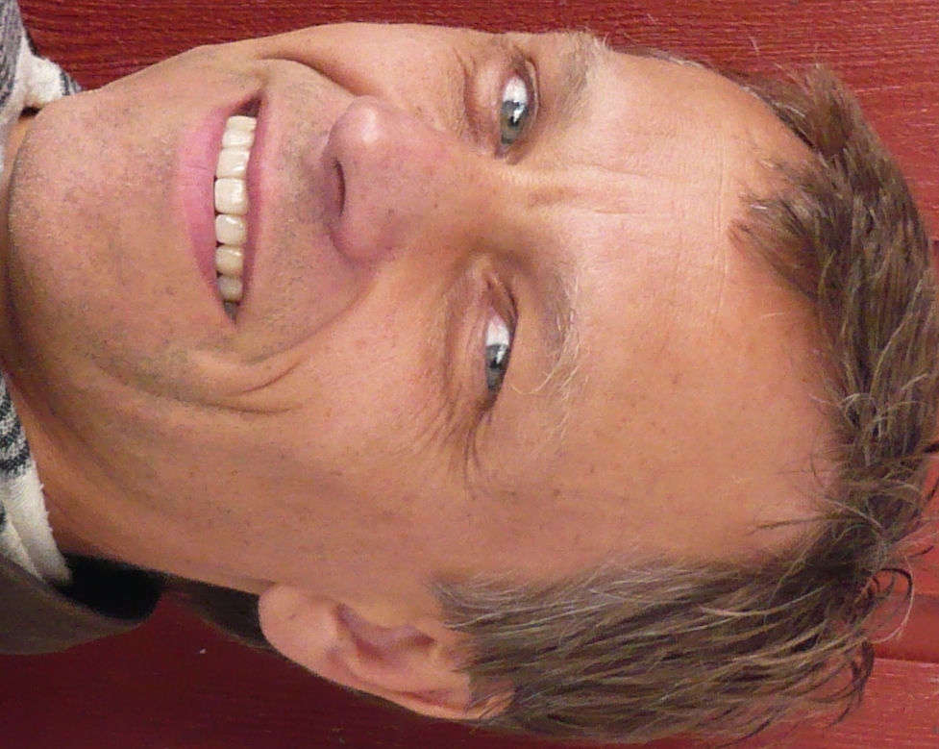

During Ida Bach Jensen's maternity leave:

JEPPE MØRCH SØRENSEN (DK)

- double bassist

Educated from The Royal Danish Music Acedemy and also studied with Eric Schmidt, Preben Meyer, Ludwig Streicher, Gary Carr a.o. After diploma in 1984 engaged by Tivoli's Harmony Orch. and Promenadeorkesteret; later in Odense Symphony Orchestra. Since 2001 member of the Royal Danish Chapel. Also appears in projects within jazz and Brasilian music.

ANDERS HVIDBERG-HANSEN (DK)

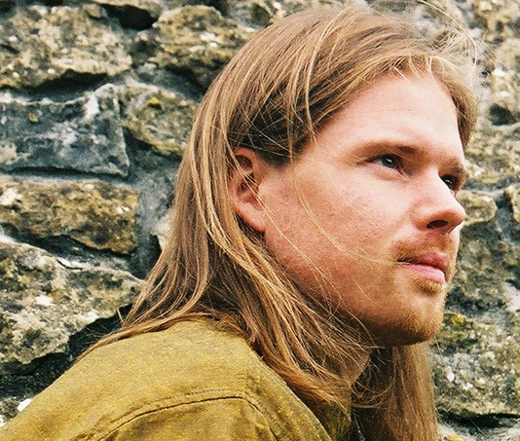

- percussionist

Has his roots in world music. Main instruments: African drums & percussion, drumset. Autodidact apart from studies with masterdrummer Okyerema Pra   
in Ghana focussing on Ghanaian polyrhythms, talking drum traditions  
and integration of drum based music and dance. Composer,   
Music for the Mysteries has recorded two pieces of his: “The Swords” and   
“La Morte non é niente". Performs in DK with Tamala, Effie & Eliten,   
Talking Drums a.o. and with various groups in Rome.   
Producer with own recording studio. <http://www.oroliquido.dk>

ICELANDIC ARTISTS



MARÍA ELLINGSEN (ISL)

- actor. The role of storyteller in Melangell

Maria Ellingsen is one of Iceland's most acclaimed contemporary actors, directors and dramaturgists. Educated from The Experimantal Theater Wing, Film and Director's section at New York University and has appeared in numerous films and tv-productions in US and in Iceland. Her break trhough was as the main character in the film "Agnes". Ever since she has played a large number of main roles, incl. at the National Theatre in Reykjavík and has also founded her own theatre company *Second Stage.* Mará Ellingsen has win many awards both as an actor and as a director. <http://www.mariaellingsen.com>

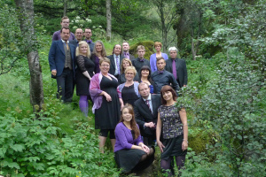

SINGERS FROM KAMMERKÓR SUÐURLANDS (ISL)

South Iceland Chamber Choir founded in 1997 comprises professional and amateur musicians from southern Iceland. The choir has a repertoire of both sacred and secular music, has premiered works by many outstanding Icelandic composers and released four CDs. Their conductor Hilmar Örn Agnarsson (b.1960) studied music in Iceland and later at Hochschule für Musik in Hamburg. Organist at Skálholt Cathedral 1991-2008; since 2009 at the Roman Catholic Cathedral in Reykjavik. <http://kammerkorsudurlands.wordpress.com/>

SWEDISH ARTISTS

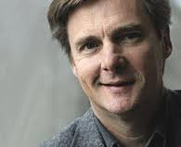

STEFAN PARKMAN (SE) - conductor

Stefan Parkman, b.1952 belongs to the most estimated Scandinavian choir conductors and appears as guest conductor of symphony orchestras all over Europe. After studiers with Eric Ericson and Jorma Panula he started his carrier in 1976 as a conductor of Uppsala Cathedral's Boys Choir. He has been chief conductor of Radio Denmark's Chamber Choir, The Swedish Radio Choir, and the Royal Philharmonic Choir in Stiockholm. In 2000 Stefan Parkman took over the Eric Ericsson chair in choir cinducting at Uppsala University. In 2013 he is appointed chief conductor of Düsseldorf Radio Choir. <http://www.uak.se/stefane.html>



SARA EKMAN (SE) - choreographer

Sara Ekman is educated at The Ballet Academy of Stockholm. She was engaged as a dancer in Copenhagen 1993-96 by Pattersson Project a.o. In 1996-98 she danced in London with Kevan Allen Dance Company.  In Sweden, Sare has worked with Dansstationens Tour Company in Lund since 1999 and has appeared in productions by Kajsa Giertz, Gunilla Heilborn, Wies Merkx, Dorte Olesen a.m.o. As a choreographer she has also gained much acknowledgement for her choreographies and direction of actors, incl. in performances at Malmö Opera and Malmö City Theatre.